Athena Lab

Contents
1 Copying DataSets to S3 and review using S3-Select From 2
1.1 Create S3 buckets in AWS Console. 2
1.2 Verify the upload to S3 bucket 4
2 Create Tables Manually via Athena Console 5
3 Create Tables using Glue Crawler 8
4 Create Views 16
5 Query Results, Save Query, History 17
6 Join query on two Athena Tables 20
7 Create CTAS queries in Athena …………………………………………………………………………….21

Copying DataSets to S3 and review using S3-Select From
Save the Attached ‘Sales.zip’ file to local machine. Extract the two csv’s to a local folder. TaxRates.csv & SalesRecords.csv

Create S3 buckets in AWS Console.
Open AWS console, and go to the S3 home page : https://s3.console.aws.amazon.com/
Create a S3 bucket with the naming convention “athena-labs-101-demo”-<random number>.
Steps to create S3 bucket Click “Create Bucket”

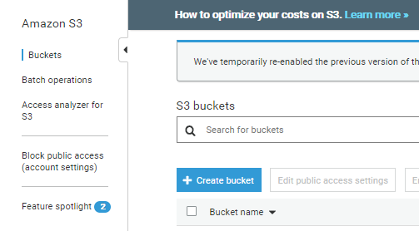

Enter the bucket name (“athena-labs-101-demo”-<random number>), Select the Region as instructed by the immersion day facilitators Click Create. Generally the region to be selected is us-west-2 : US West (Oregon)
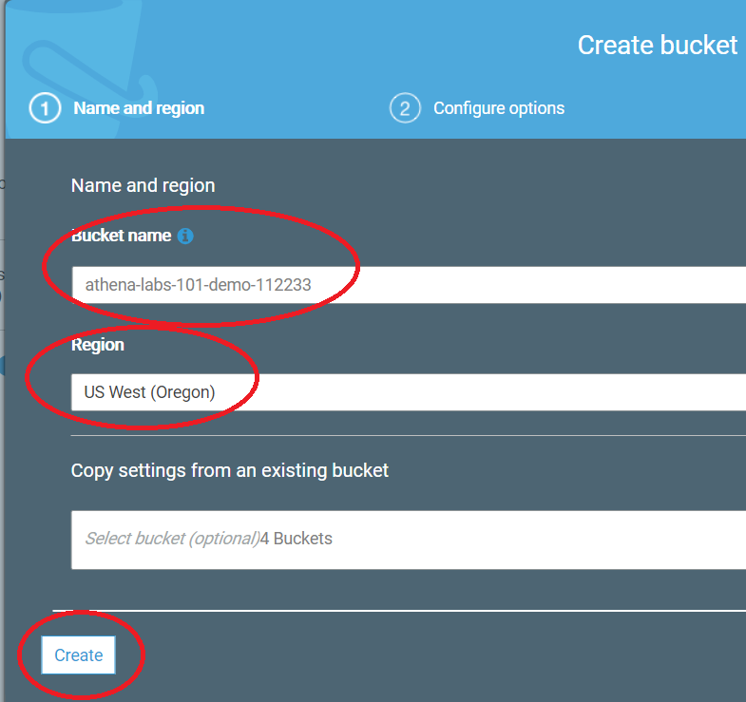

Within the Bucket, create three folders as
- SalesRecords
- TaxRates
- Athena-queries
Select the bucket created in previous step. Click on “Create Folder” , specify the folder name Save.
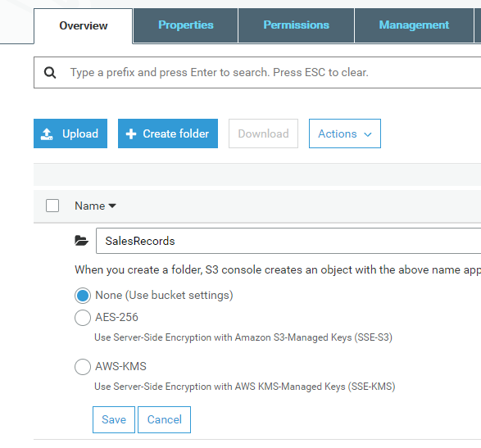

After the three folders are created they should appear as below in S3 bucket.
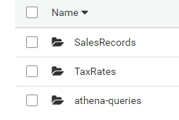

Upload the files to respective buckets. Select the Folder, click on “Upload”, Click “Add files” browse to the file, Click Upload.
- Upload the “SalesRecords.csv” to “SalesRecords” bucket
- Upload the “TaxRates.csv” to “TaxRates” bucket.
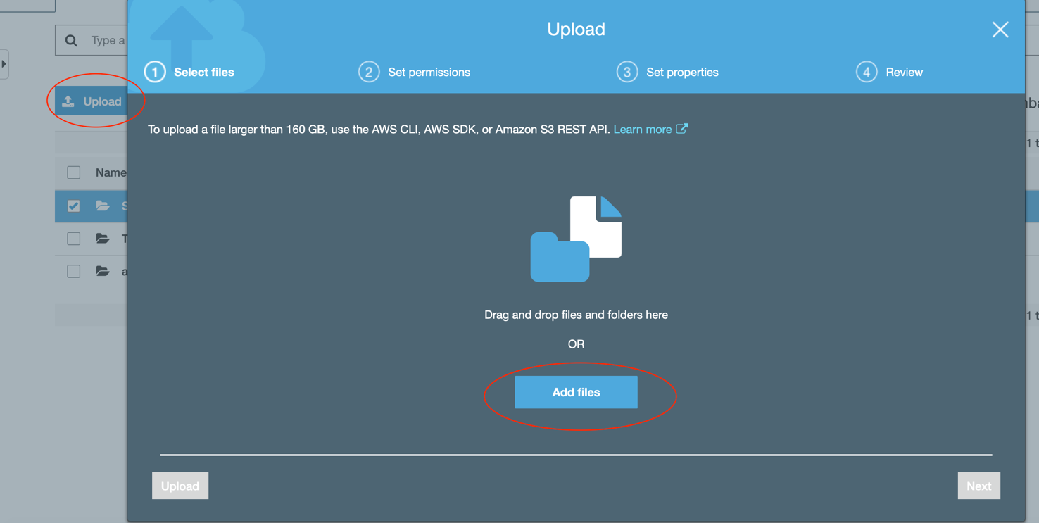

Verify the upload to S3 bucket
Browse to the S3 object file “SalesRecords.csv”. Select the checkbox on the file name. Click on “Select From” button.
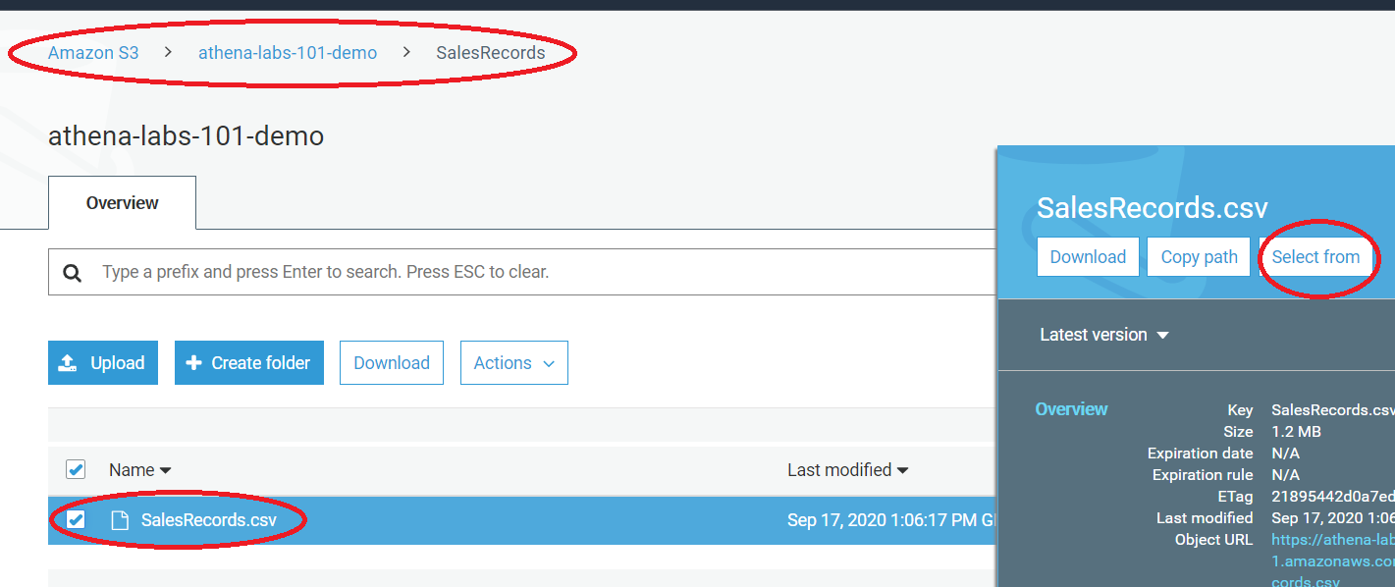

Keep the default settings. File format = “CSV”, compression = “None”. Click on “Show file Preview”. It will display the file contents.
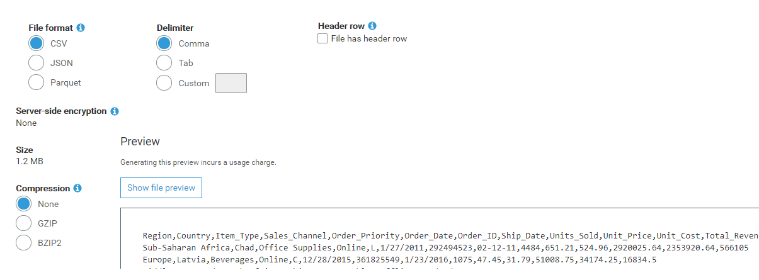

Create Tables Manually via Athena Console
Open the Athena Console : https://console.aws.amazon.com/athena/
If it is the first time you are using Athena in this account, click on “Get Started”. Confirm the region selection on top right side of console.
This is the Athena console
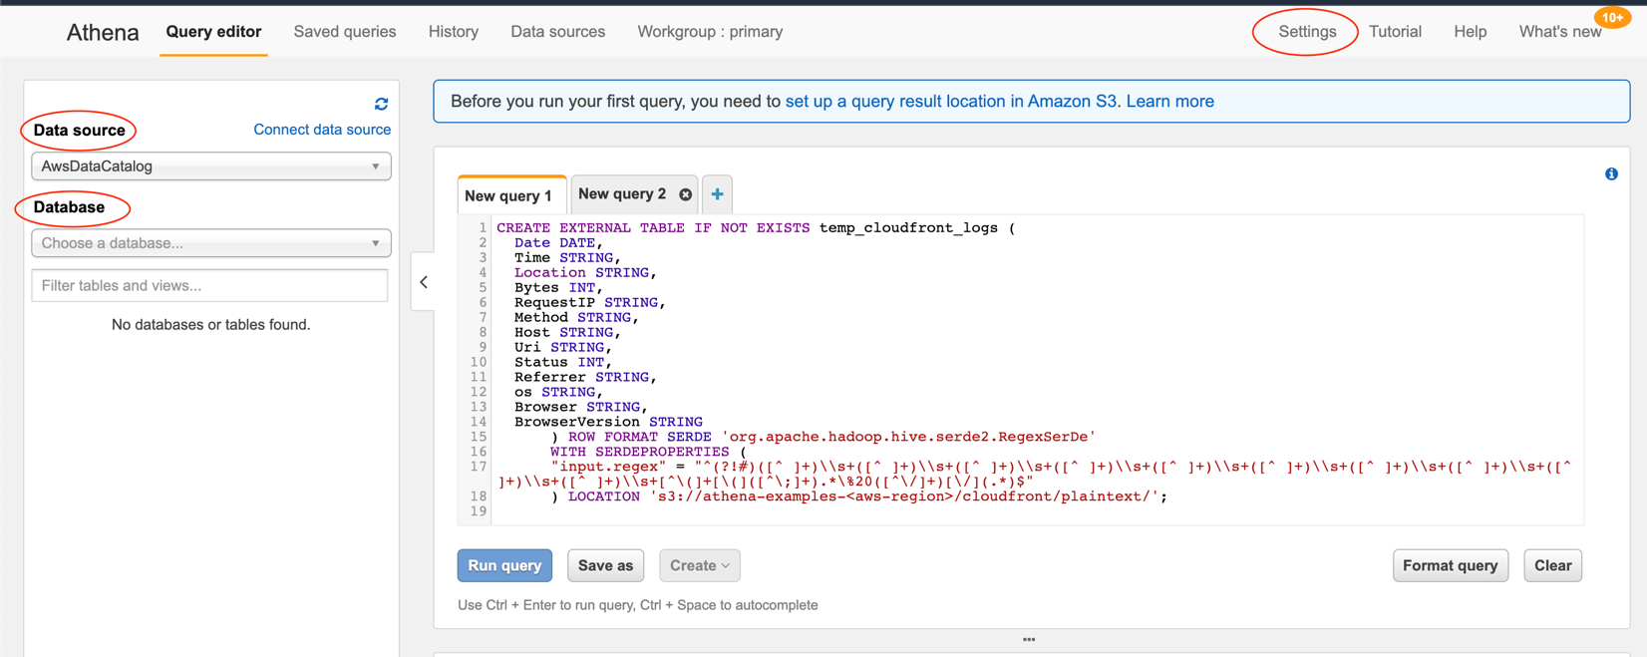
Click on Settings (towards right – top). Specify the S3 bucket for “Query result location”. This is same folder we created in previous step.

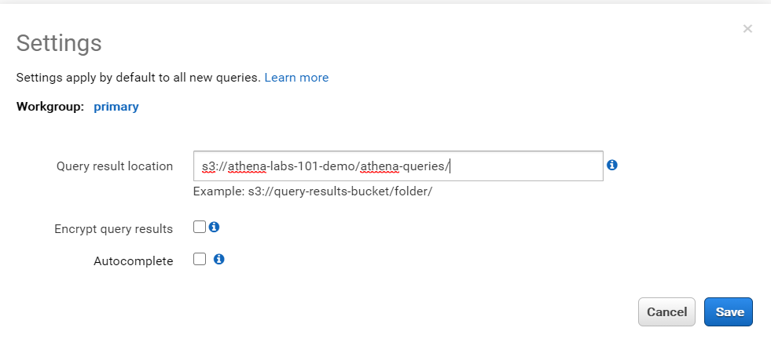

Copy-Paste the below query to Athena console, and click “Run Query”
Replace the <aws-region> with your region code. Take care there are no spaces.
E.g. LOCATION 's3://athena-examples-us-west-2/cloudfront/plaintext/';

CREATE EXTERNAL TABLE IF NOT EXISTS temp_cloudfront_logs (
Date DATE,
Time STRING,
Location STRING,
Bytes INT,
RequestIP STRING,
Method STRING,
Host STRING,
Uri STRING,
Status INT,
Referrer STRING,
os STRING,
Browser STRING,
BrowserVersion STRING
) ROW FORMAT SERDE 'org.apache.hadoop.hive.serde2.RegexSerDe'
WITH SERDEPROPERTIES (
"input.regex" = "^(?!#)([^ ]+)\\s+([^ ]+)\\s+([^ ]+)\\s+([^ ]+)\\s+([^ ]+)\\s+([^ ]+)\\s+([^ ]+)\\s+([^ ]+)\\s+([^ ]+)\\s+([^ ]+)\\s+[^\(]+[\(]([^\;]+).*\%20([^\/]+)[\/](.*)$"
) LOCATION 's3://athena-examples-<aws-region>/cloudfront/plaintext/';

Once the Results window shows “Query Successful”, you will see a table created (temp_cloudfront_logs) on left side.
Click the three dots, and Preview-Table. It will create a query command automatically as
SELECT * FROM "default"."temp_cloudfront_logs" limit 10;
Click “Run Query” to check the output.

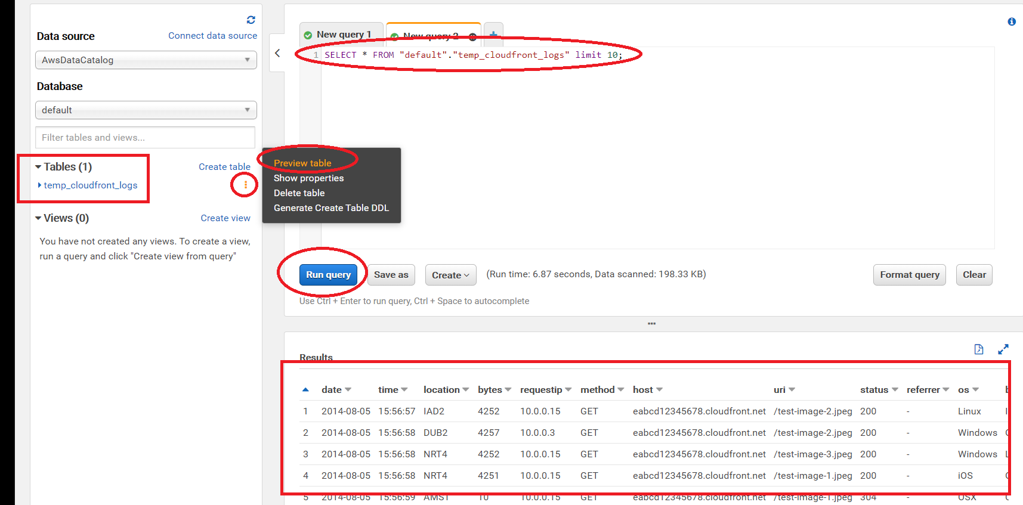

Create Tables using Glue Crawler

Open the Glue console : https://console.aws.amazon.com/glue
Check the Region on right side top : it should be the same as the bucket.
Click Crawlers Add Crawler

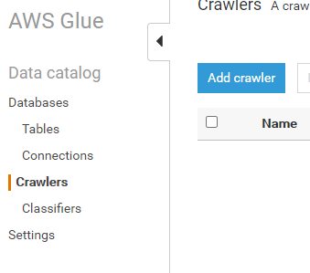

Crawler name : SalesRecords
Crawler source type : Data Stores
Choose data store : S3
Connection (keep blank / default)
Crawl data in Include Path : point to the S3 bucket (Not the CSV File)

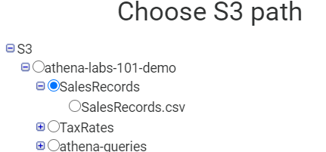

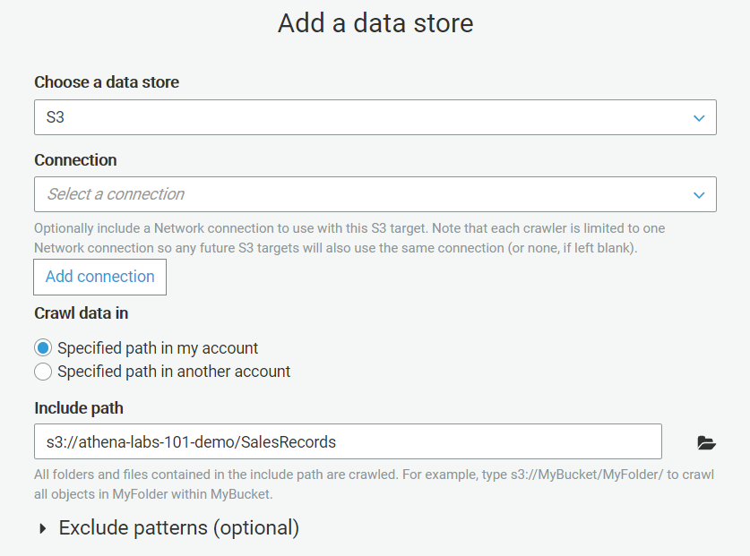

Add another data store “No”
Select Create an IAM role
AWSGlueServiceRole- athena-demo

Frequency “Run on demand”
Configure the crawler's output
Database Add Database “sales”

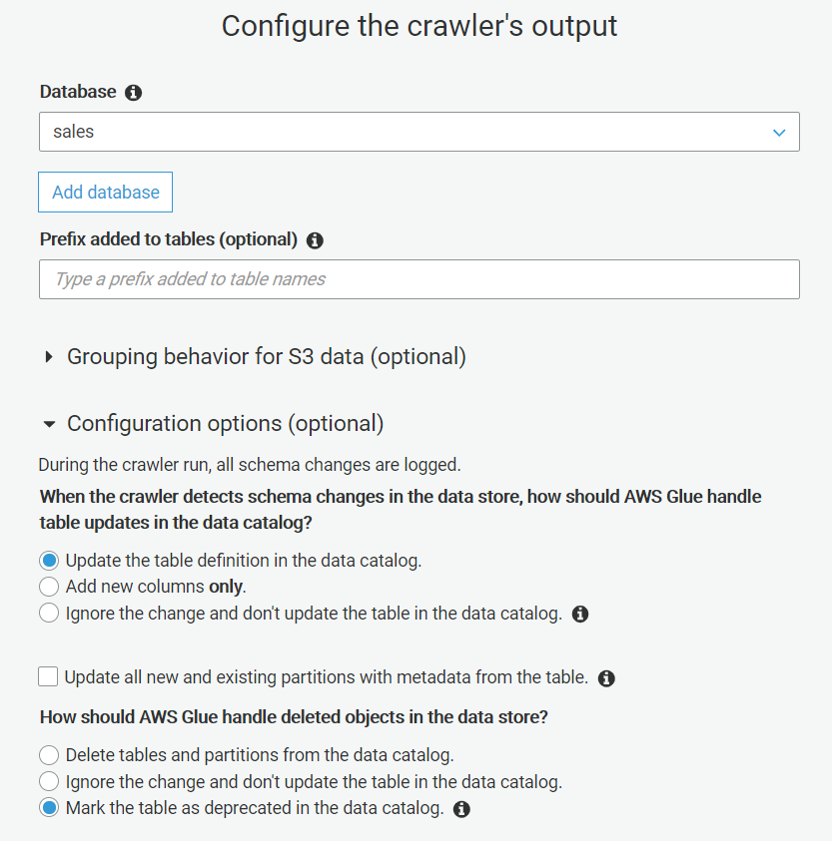

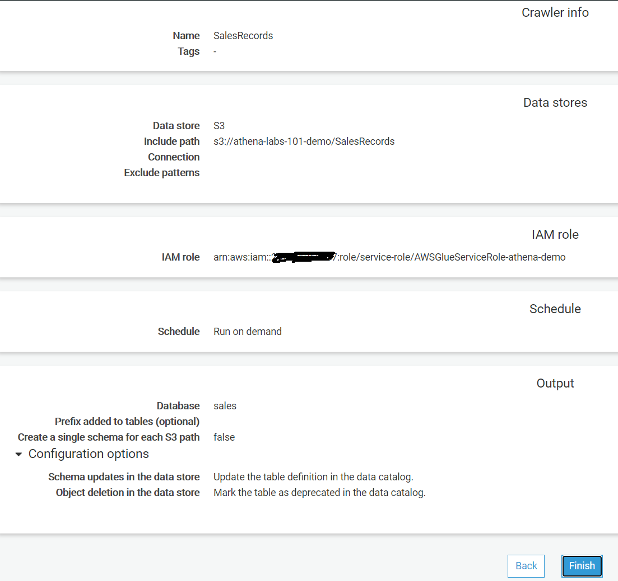

Repeat the process to add crawler : for the TaxRates , and point to “TaxRates” S3 folder.
In the Choose an IAM role, create a new role for this crawler.
Choose Database as “Sales”

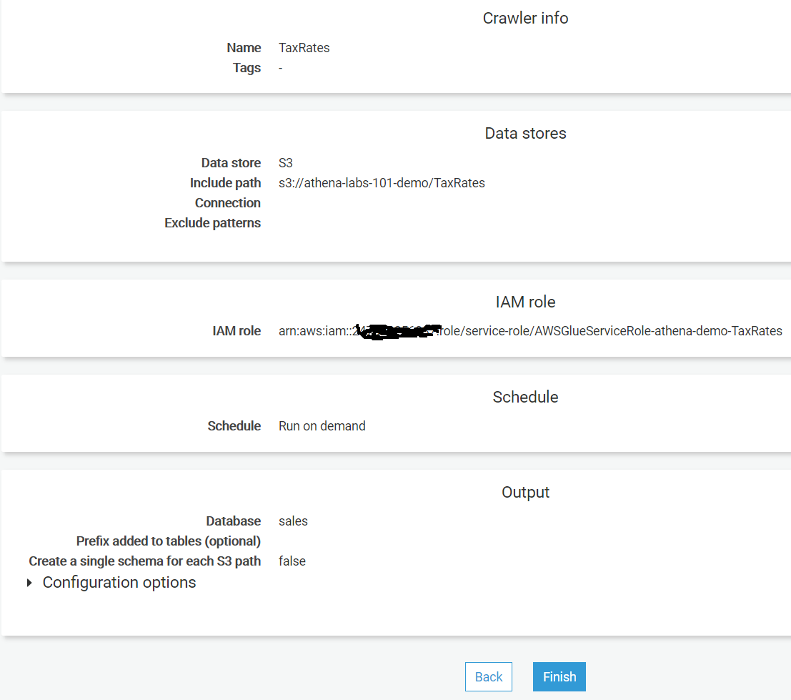

Select each Crawler one by one (SalesRecords and TaxRates), and click “Run Crawler” button.
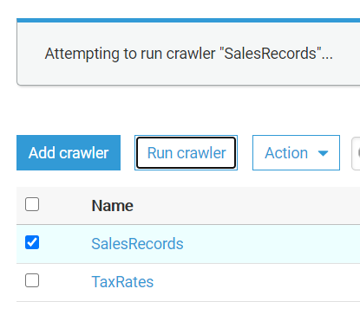

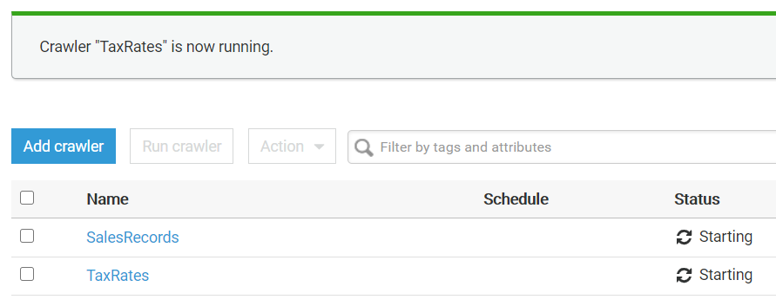

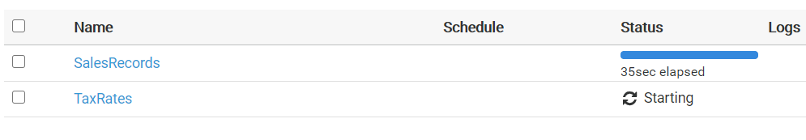

Wait for both the crawler to finish and status shows “Ready”. On left side, click on “Tables”, you will see two tables created.

Select each table one by one, and click “Action” “View Data”. It will open the Athena console.
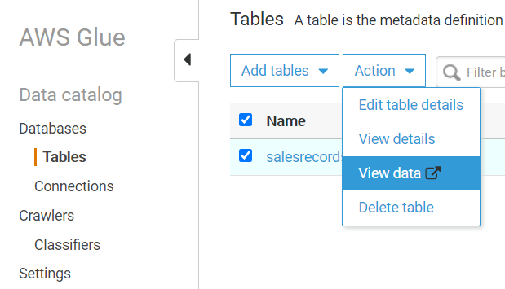

You might get this prompt “Preview data”, select “Don’t show again” to avoid repeating this prompt.
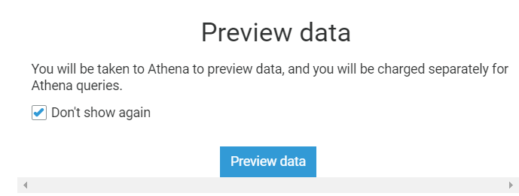

Here on Athena console Ideally, the default query will load in query window, if not, then select the table three dots and click on “Preview table”

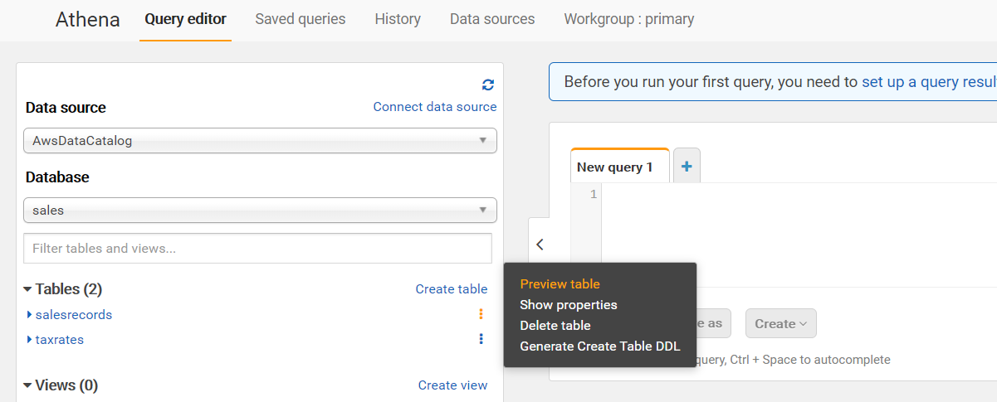

You can try a few simple Athena queries
SELECT * FROM "sales"."salesrecords" limit 10;

SELECT * FROM "sales"."taxrates" limit 10;

SELECT region,
sum(total_revenue)/1000000 AS total_revenue_mn
FROM "sales"."salesrecords"
GROUP BY region;

SELECT country,
sum(total_revenue)/1000000 AS total_revenue_mn
FROM "sales"."salesrecords"
where region = 'Europe'
GROUP BY country;

Create Views
Open the Athena Console : https://console.aws.amazon.com/athena/
Ensure you have the correct region selected in top-right.
Execute the below query to create a View, and then to query the view. Once the query finishes, you will see a view created on left side “Views” asia_revenue.

CREATE view Asia_Revenue AS
SELECT country,
(sum(total_revenue)/1000000) AS total_revenue_mn
FROM "sales"."salesrecords"
WHERE region='Asia'
GROUP BY country
ORDER BY total_revenue_mn DESC ;;

To get the Top 10 revenue countries from view Asia, try the query, or preview the table.
SELECT * FROM "sales"."asia_revenue" limit 10;

Query Results, Save Query, History

You can try some complex queries on Athena.
SELECT region, sum(total_revenue)/1000000 as total_revenue_mn FROM "sales"."salesrecords" group by region;

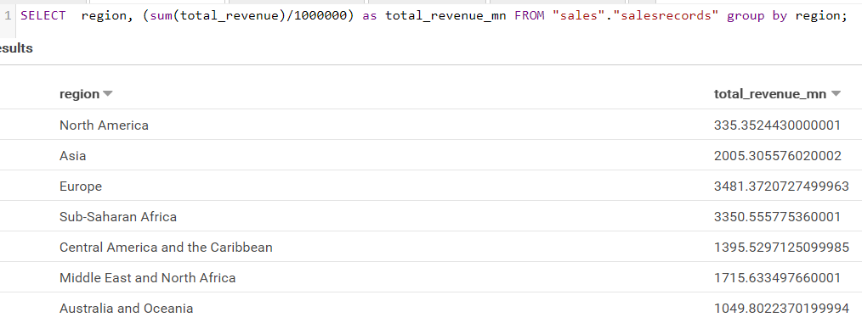

Formatting a query.
Copy-paste the query in Athena console.

SELECT country, sum(total_revenue)/1000000 AS total_revenue_mn FROM "sales"."salesrecords" where region = 'Europe' GROUP BY country;

Click on “Format Query button”, on right side. It will format the query in easy to read query.
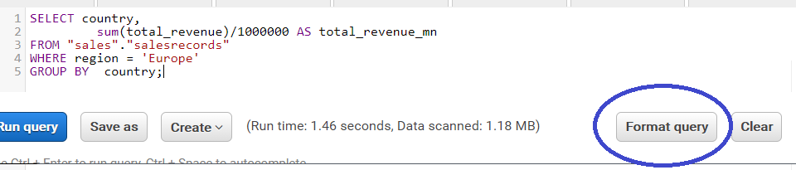

To save the query results as CSV, click on the “Download the result in CSV Format” button.
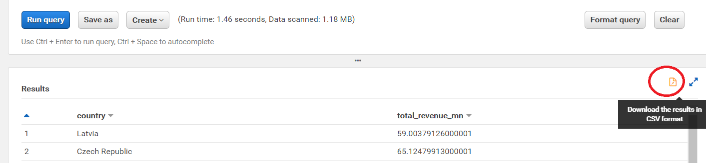

To Save a query, click “Save as”
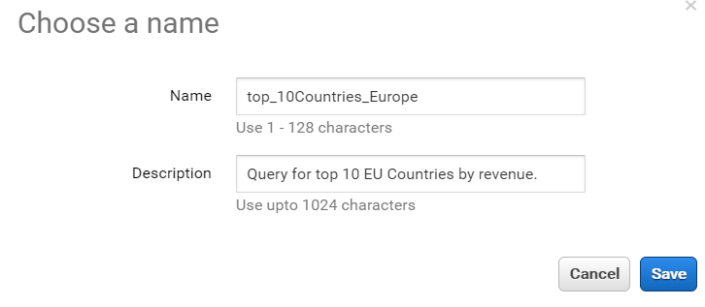

Click on “Saved Queries” tab to check and re-use the query. Double click the query to open the query, and to run it.

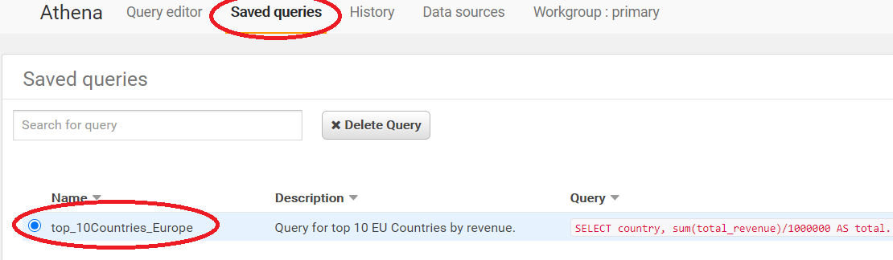

Explore the History Tab for historical queries.
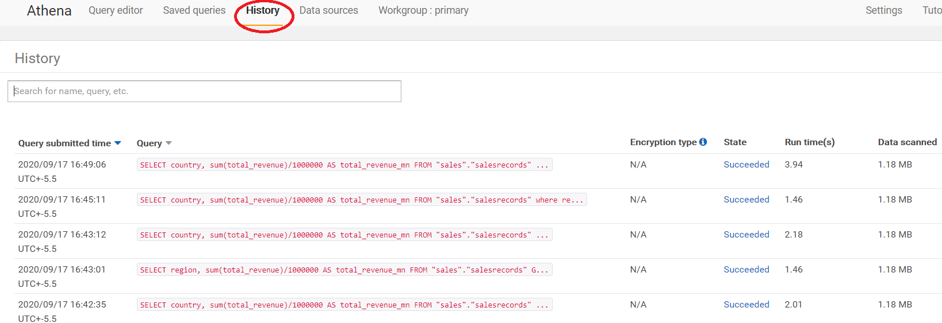

Join query on two Athena Tables

This query will join two tables, and display the results
SELECT salesrecords.region,
salesrecords.order_priority,
salesrecords.item_type,
salesrecords.order_id,
salesrecords.total_revenue,
taxrates.tax_percentage,
cast(((salesrecords.total_revenue * taxrates.tax_percentage)/100) AS integer) AS taxes
FROM sales.salesrecords
INNER JOIN sales.taxrates
ON salesrecords.item_type=taxrates.item_type;

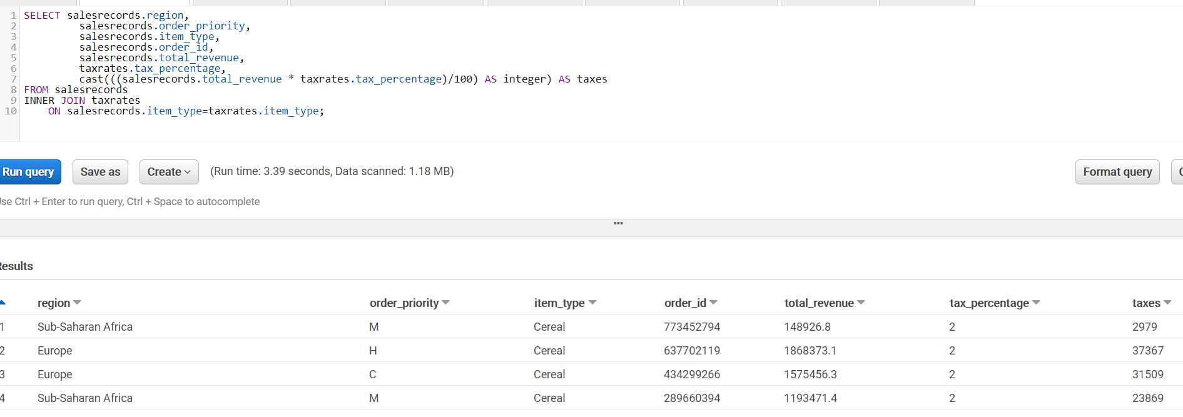

Download the CSV to local machine and inspect.

Create CTAS queries in Athena

This query creates a new table(salesrecordsnew) by copying all columns from a salesrecords table

CREATE TABLE salesrecordsnew AS
SELECT *
FROM salesrecords;

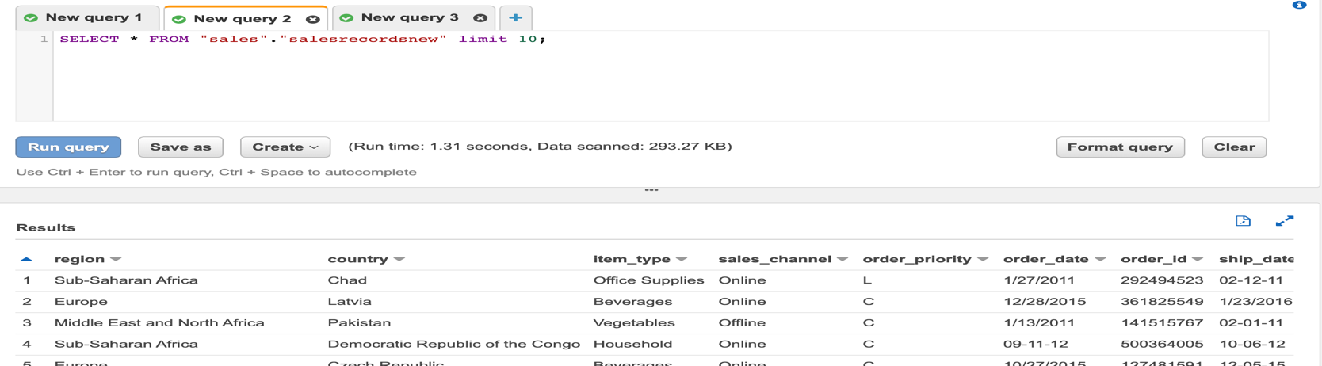

You can try few Athena queries for CTAS
CREATE TABLE sales.salesrecordsnodata
AS SELECT *
FROM sales.salesrecords
WITH NO DATA;

CREATE TABLE sales.sales_records_compressed
WITH (
format = 'Parquet',
parquet_compression = 'SNAPPY')
AS SELECT *
FROM sales.salesrecords;

CREATE TABLE sales_ctas_json
WITH (
format = 'JSON',
external_location = 's3://<Bucket Name>>/sales-json/')
AS SELECT
salesrecords.region,
salesrecords.order_priority,
salesrecords.item_type,
salesrecords.order_id,
salesrecords.total_revenue
FROM sales.salesrecords;

